Kindergarten Supply List

- 1 - 24 pack of Crayola Crayons (regular size)
- 6 – small glue sticks
- 2 - boxes of tissues
- 4 - BLACK dry erase EXPO markers (chisel tip)
- 1- box of gallon size ziplock bags
- 1- ream of white copy paper
- 2 – container of disinfectant wipes
- 2– bottles of hand sanitizer (12 oz or larger)
- $20.00 extra supply fee (used throughout the year for extra projects/supplies)

*** WISH List ***
(If you can provide ANY of these extra items it would be greatly appreciated.)

1 – package of clear sheet protectors
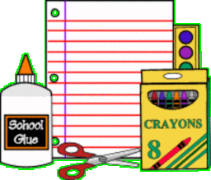
1 – box of color pencils
1- package of fine tip Expo markers
1-box of Crayola markers


*THANK YOU very much for your
support.

